PROJECT REPORT

LITERATURE REVIEW DRAFT-I

**LOW COST CARBON MONOXIDE SENSOR FOR INDUSTRIAL APPLICATION**

REPORT BY

AKSHAY SRIVASTAVA

# INTRODUCTION

Growing emission rates as a result of increased industrialization coupled with a lack of environmental norms has resulted in an alarming rise of toxic gases in the atmosphere. Though severe measures have been recommended in the Emission Gap Report 2019 published by United Nations[1] absence of an effective monitoring system for the real-time measurement of the concentration of these species in ambient air hinders the process of implementing these actions. Though air quality is measured as a function of the concentration of several gases such as NOx, SOx, HC, CO2 etc. the scope of this report shall be limited to the real time measurement of Carbon Monoxide. Since Carbon Monoxide is colourless, odourless, and tasteless, in nature, it poses significant harm to human health as it can lead to death. Furthermore, as direct detection of CO by humans is impossible, it is imperative to develop an effective and cost-efficient sensor system that can detect, and measure CO. Both natural and artificial sources can create carbon monoxide gas. The highest amount of exposure usually happens indoors, in places, such as garages, kitchens, etc. CO is generated during combustion that takes place in combustion engines, stoves, water heaters, generators, lanterns, and gas ranges or during burning charcoal and wood[2]. Acute exposure to carbon monoxide poisoning can result from the combustion of any fossil fuel. Other sources of long term exposure include vehicle exhaust, smoke and industrial emission[3][4][5][6][7].

A small amount of CO over a long period of time or a large amount of CO over a short period of time can kill a person within seconds to hours depending on the dose. The concentration of carbon monoxide is measured in parts per million (ppm) and parts per billion (ppb). High concentrations of CO can immediately affect vital organs and long-term exposure to low concentrations of CO can also create severe health issues (to children and to the foetuses of pregnant women). A summary of health problems caused by exposure to CO is presented in Table 1, where the problems are listed according to concentration and exposure34567.

*Table 1: Health consequences of Carbon Monoxide Poisoning at different concentrations*

|  |  |
| --- | --- |
| Concentration- CO | Health Consequences |
| 35 ppm | Headache and dizziness withing 6-8 Hours of constant exposure |
| 100 ppm | Slight Headache in 2-3 Hours |
| 200 ppm | Slight Headache within 2-3 Hours; loss of judgment |
| 400 ppm | Frontal Headache within 1-2 Hours |
| 800 ppm | Dizziness, nausea, and convulsions within 45 Min; insensible within 2 Hours |
| 1600 ppm | Headache, tachycardia, dizziness and nausea within 20 Min, death in 2 Hours |
| 3200 ppm | Headache, dizziness and nausea in 5-10 Min. Death within 30 Min |
| 6400 ppm | Headache and dizziness in 1-2 Min. Convulsions, respiratory arrest and Death in >20 Min |
| 12800 ppm | Unconsciousness after 2-3 Breaths. Death in less than 3 Min |

# SENSOR PARAMETERS

Since carbon monoxide cannot be detected directly, sensors used to determine CO concentrations do so by the nature of interaction of CO with other compounds and radiations such as Infrared. These different sensing mechanisms provide different perks and pitfalls depending upon the requirements and scenario specific standards that the sensor has to match. A few of such requirements are as follows:

1. Sensing Conditions: These include the surrounding physical conditions of the sensor such as the humidity, pressure and temperature which may influence the accuracy of sensor output. For example, electrochemical sensors can detect of CO well but their sensitivity is a function of surrounding temperature and humidity[8].
2. Sensitivity: From control system theory, sensitivity is defined as “*the ratio between the output signal and measured property*”[9]. In the case of gas detection, the same definition may be translated into the minimal concentration of the gas which the sensor can reliably detect. This may be in the range of parts per million, parts per billion and so on.
3. Selectivity: Sensors that can selectively detect specific species are known to be highly selective in nature, but on the contrary sensors with low selectivity are known to be cross sensitive. This means that though the sensor may offer good detection of a specific gas, it does for a range of different compounds. For example, though SnO2 based MOS sensors are known to offer exceptional conductivity changes on exposure to CO, they also do the same for other reducing gases such as combustible gases[10].
4. Responsibility: This criterion is dependent on two key properties of any sensor, namely[11]
   1. Response time: Response time is the time for responding to a step concentration change from 0 to 90% of the saturated value.
   2. Recovery time: Recovery time is the time required for the sensor signal to return to 90% of the initial value.
5. Stability and Reversibility: Stability in this case refers to the compound and structural stability of the active sensing element in the sensor for a given range of physical and chemical operating conditions. For example, SnO2 nanofilms with thickness comparable to the Debye length (~10nm) are highly CO sensitive but only retain their stability below 400oC[12]. Reversibility on the other hand indicates the ability of the sensing element to go through continuous detection cycles of increment and decrement in the concentration of the target gas.
6. Power Consumption: The amount of energy required to power the sensor. This includes the electrical system and the heating system on-board[13].

# SENSING MECHANISMS

Depending upon the above requirements, the CO concentrations may be detected by one of the following type of sensors each with a different sensing mechanism:

## Metal Oxide Semiconductor based CO sensing:

Metal Oxide Semiconductor (MOS) sensors work on the principle of chemiresistance: in air, at temperatures between 150 and 400°C, oxygen is adsorbed at the surface of the metal oxides by trapping electrons from the bulk with the overall effect of increasing the resistance of the sensor, for n-type materials, or decreasing it, for p-type materials. In the presence of reducing or oxidising gases the interaction of the adsorbed oxygen releases or traps charge carriers hence effectively reducing or increasing the conductivity proportionally[14]. The majority charge carriers in pure semiconductors are controlled by proper doping of donor or acceptors[15]. However, the majority charge carriers in metal oxide based semiconductors is determined either by the presence of cations of different valance (aliovalent cations)[16] or by a disproportionate presence of oxygen (oxygen non-stoichiometry)[17]. For example, intrinsic oxygen deficient SnO2 shows n-type semiconductivity due to the formation of oxygen vacancy[18] while in similar nature NiO exhibits p-type semiconductivity because of deficiency of metal ions in the material[19]. MOS based CO sensors may further be subdivided into the following categories depending upon the type of semiconductor (or more specifically, the majority charge carriers present in the thin film) used in the sensor:

* 1. N-type Metal Oxide Sensor: N-type MOS sensors are the most common class of gas sensors available on the market[20]. The working of n-type MOS sensors may be understood well by the simplified depiction in Fig.1. At 100-500oC, oxygen molecules adsorb into the surface of the MOS and form adsorbed ionized species such as O2-, O- and O 2- by electron transfer from the n-type semiconductor (rich source of electron charge carriers) to the atmospheric oxygen molecules (Fig 1.a.)[21][22]. The adsorption of ionized oxygen atoms (ionosorption) occurs readily at temperatures <150oC for O2-, between 150-400oC for O-, and at >400oC for O2- 22. This results in the formation of an electronic core-shell configuration (Fig.1.b.) with a conductive electron rich core and an electron deficient depletion layer shell. In the presence of a reducing gas (CO in this case), the adsorbed ions oxidise the gas to a higher oxidation state releasing an electron into the semiconductor shell hence increasing the overall conductivity. This rise and fall in conductivity is proportional to the concentration of the reducing gas in the atmosphere19.

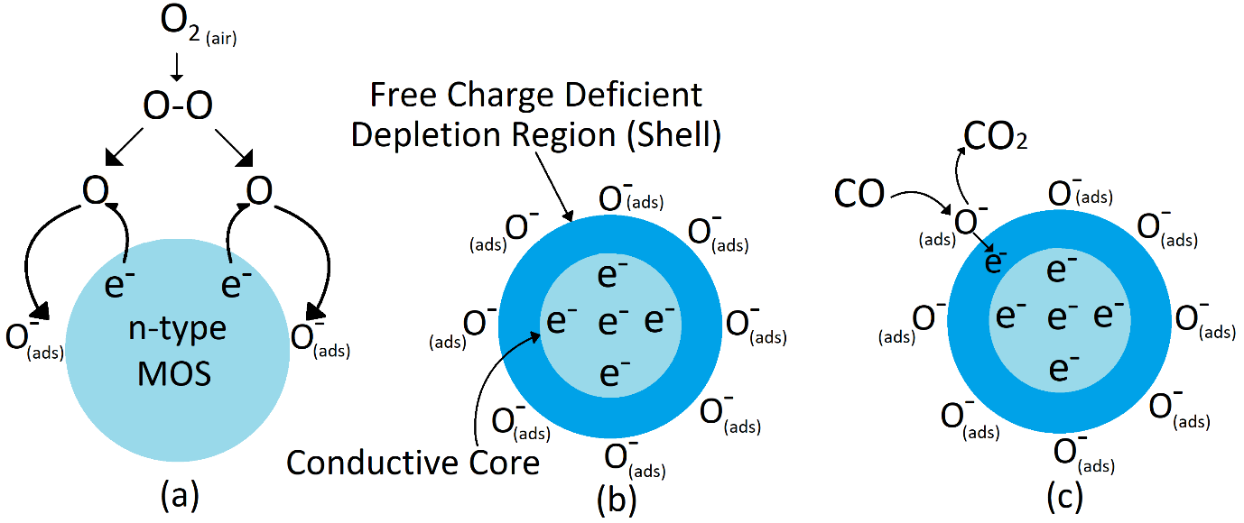

Figure 1: Formation of Shell-Core in n-type Metal Oxide semiconductor. (a). Adsorption of oxygen ions (ionosorption) onto the surface of the semiconductor grain. (b). Migration of electrons from the bulk to surface to form a charge deficient depletion region (shell). (c). Oxidation of reducing gas and subsequent ejection of electron into the semiconductor particle consequently increasing conductivity.

The overall performance of an n-type MOS gas sensor may be improved by selecting appropriate material for construction, increasing the surface area available for reaction or by the means of doping. Though a wide range of materials are available for the construction of a n-type MOS gas sensor, SnO2 is the most commonly used. This is so because it provides high sensitivity in case of Carbon Monoxide sensing. In previous literature, SnO2 nanowires were used for the detection of CO. Kolmakov et. al[23] electrodeposited tin-nanowires through porous anodic alumina and used ultrasonication to break free individual tinoxide wires which were then deposited onto Si substrate and Au/Ti electrodes were used to record the overall response. The main aim of this study was to determine the optimum diameter of nanowire for the detection of CO, which was obtained to be ~60nm. Through literature review it was evident that SnO2 layers, wires in the range of Debye length were most responsive. Brunet et. al.[24] performed a comparative study on the performance of SnO2 thin films and nanowires for the detection of reducing gases. The group used spray pyrolysis in open air for the preparation of the nanostructures and Au/Ti electrode contacts for measuring sensor response. Sensor response increased with increasing temperature and evidently peaked at 300-350oC for thin film (for common reducing gases such as CO, CH4, SO2, H2S) but was significantly dependent on gas species in the case of thin wire. An approximate response and recover time for CO detection at 350°C was found to be 28s and 94s for SnO2 thin film (50nm thickness) and 25s and 28s for SnO2 nanowire (200nm diameter) sensor. ALD based thin layer deposition explored by Du et. .al[25]. The best response was obtained for a film thickness of about 2.62nm at a temperature range of 300-325°C. Composite materials were also used for enhanced selectivity and better sensor response. Kim et. al.[26] explored ZnO-SnO2 core-shell nanowires for optimizing sensing behaviours to reducing gases such as CO and HC's. ZnO-SnO2core-shell nanowires with different shell thicknesses (0–120 nm) were prepared using Atomic layer deposition. Though these sensors were tested for low concentration detection (10ppm), at response time of 9s and a recovery time of 57s was obtained for CO at a temperature of about 300°C. Zhao et. al.[27] explored multi-walled carbon nanotube doped SnO2 nanoparticles (MWCNT/SnO2) for sensing the CO gas. They measured the response (4 min) and recovery (10 min) time at 300°C. Unlike interfacial shell-core arrangement as in Kim et. al, doping is also used in order to increase sensor performance. In most cases, doping with noble metals is preferred as they effectively catalyse oxidation reactions and remain stable. For example, Pt/SnO2[28] where sensor detection was determined by the catalyst activity (percentage oxidation of between 150-350°C. Bahrami et. al[29] studied the enhanced sensitivity to CO in presence of other reducing hydrocarbon gases for gold nanoparticle doped sensor. It was found that the optimum temperature for sensor operation was in the range of 200-300°C since a peak in response of obtained for CO while other methane and propane did not register a significant profile change. In Moon et. al[30], CO and H2 selectivity was studied for CuO-doped SnO2–ZnO composite gas sensor. SnO2–ZnO composites were fabricated and the surface was coated with CuO and the conductivity was examined between 80-450°C. As a result of the coating, the sensor was able to operate at relatively lower temperatures and had increased selectivity (for CO detection at about 150-250°C). The response time also decreased as a result a faster response was obtained. CuO doped SnO2[31] and ZnO doped SnO2[32] were also studied separately by kumar et. al and Chester et. al. It was found that CuO doped SnO2 bilateral thin film showed excellent response towards 5-500ppm CO. A test response time at 100ppm CO at 180°C was 18 seconds and a recovery time of 78 seconds. It was also found that the senor exhibited stable response (±10% accuracy) for a period of 3 months. For ZnO-SnO2 thin films (98%-2%, ZnO to SnO2 wt%) prepared by sol-gel method, the sensor was able to detect low concentration of CO (as low as 5 ppm) with a response time of 120s and a recovery time of 280s at an operating temperature of 300°C. Besides SnO2, TiO2 nanostructures have also been demonstrated as viable construction material for CO sensors. Ibrahim et. al[33] tested TiO2 thin films grown on a range of substrates (glass, silicon and sapphire) by sputter deposition technique. Maximum response was obtained at 200°C on glass however, the largest response was obtained for sapphire at 300°C among all the substrates. Moon et al.[34] fabricated NTHH (nanostructured TiO2 hollow hemisphere) based CO gas sensors via the deposition at room temperature and at high temperature calcination. They found almost20 times higher percentage of resistance change at 250°C for 1–500 ppm CO gas compared to plain TiO2 thin film. Lee et. al[35] studied the effect of MWCNT (multi-walled carbon nanotube) doping in TiO2 xerogel thin film and it was found that the response time increased very significantly (4s for 50ppm CO at 300°C)

1. P-type metal oxide sensor: P-type MOS sensors are the not as common as their n-type counter parts20. This can be attributed to their lower response to CO, higher manufacturing cost and relatively less stability at lower temperatures as compared to n-type MOS sensors[36][37][38]. The working of p-type MOS sensors is in similar manner as n-type MOS sensors. These sensors too work by the adsorption of oxygen onto the surface and consequent oxidation of the reducing gas which inflicts changes to the electrical properties of the semiconductors. The difference lies in the transfer of holes in place of electrons and the subsequent decrement in conduction as shown in Fig.2. At 300-450K, electron hole pairs split into the constituting particles. The electrons thus ejected allow for ionosorption. Upon surficial oxidation, the ejected electron recombines with a hole on the surface and forms an electron hole pair reducing the conductivity.

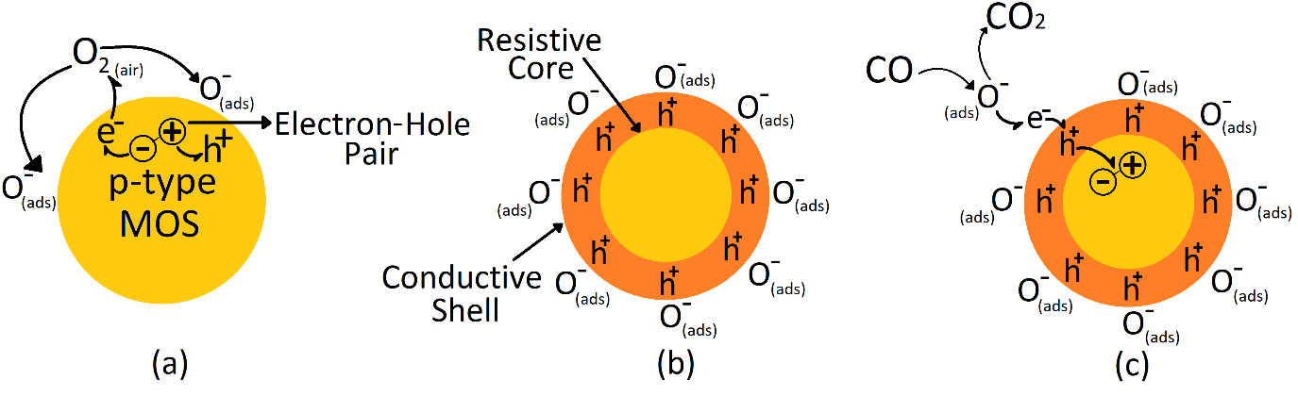

Figure 2: Formation of Shell-Core in p-type Metal Oxide semiconductor. (a). Splitting of an electron-hole pair releasing an electron causing adsorption of oxygen ions (ionosorption) onto the surface of the semiconductor grain. (b). Increase in the hole concentration on the surface resulting in the formation of conductive shell and a resistive core. (c). Oxidation of reducing gas and subsequent ejection of electron causing the formation of electron-hole pair resulting in the reduction in the conductivity.

Generally, p-type metal oxides semiconductors show lower response to CO than n-type MOS. Cobalt Oxide, Nickel Oxide and Copper oxide are extensively investigated p-type MOS for CO gas sensing application. Anatase TiO2 films on silicon substrate by Electron beam evaporation based CO gas sensor were developed by Wöllenstein et. al[39] and the effect film thickness, substrate and temperature on CO detection were studied. Sensor Configuration is as shown below:

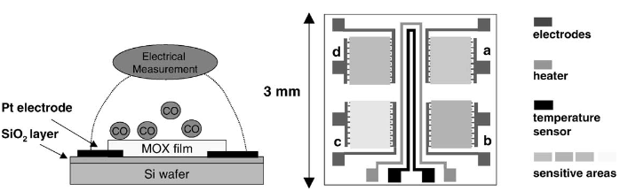

Figure 3: Schematic cross-sectional view of one sensor element (left) and layout of the 2x2 sensor array on the oxidised Si substrate (right): interdigital electrodes, heater and temperature sensor are made of Pt/Ta films. Diagram reproduced from Wöllenstein et. al**39**.

Optimum operation temperature was found to be between 180-280°C. At higher temperatures, the sensitivity to CO decreased significantly upto the pint of no relative activity to CO concentrations. An average response time to CO was found to be 8 min. But the sensor also exhibited sensitivity to other gas species such as methane, hydrogen, nitrogen dioxide and ammonia. Tan et. al[40] studied Co3O4 micro-rods fabricated for CO gas sensing. They reported a sensitivity (~2) at 100 ppm CO concentration at 220°C. P-type metal oxides doped with n-type metal oxides have also been used for detection of CO since n-type materials are relatively more sensitive in nature. Such heterojunctions have been reported in previous literature for CO[41][42][43] and extensively for other gases such as H2 by Huang et. al[44] and for NH3 by Guang et. al[45]. Similar to n-type metal oxide, p-type metal oxides can also be doped with noble metals in order to enhance sensor responsive and stability. Wu et. al[46] found that a sensing head coated withAu/Co3O4could detect CO at temperatures above 130°C whilst the response time of the said sensor reduced from 60 to 20 s.

## Electrochemical cell based CO detection:

Electrochemical sensors work on the principles of electoanalytics: The signal generated by an electrochemical sensor is usually derived from an electrical response upon the presence of an analyte [47]. Several classes of electrochemical sensors exist, each employing a different method within the domain of electoanalytics. The table below lists some of the main electrochemical methods and their respective monitored electrical signals [48].

*Table 2: Electrochemical methods of detection and monitored electrical signals*

|  |  |  |
| --- | --- | --- |
| Electrochemical Methods | Monitored Electrical Properties | Units |
| Potentiometry | Potential Different (volts) | V |
| Conductormetry | Resistance (ohms) | Ω |
| Amperometry & voltammetry | Current (amps) as a function of applied potential | I |
| Coulometry (Q) | Current as function of time (coulombs) | C=I.s |
| Capacitance (C) | Potential load (farads) | F=C.V-1 |

The scope here shall be limited only to the electrochemical methods most commonly applied to the gas sensing. These include amperometric and potentiometric gas sensors [49]. Though each of these have been elaborated upon below, since their basic analytic mechanism revolves around the adsorption of a gas on an electrode causing electrochemical reactions thereby generating an electrical signal, the basic sensor design is rather similar. A few of common design variables in the layout of an electrochemical sensor are as mentioned below:

1. Electrolyte: The sensor designs below are mainly explained using examples of liquid phase electrolytes, but industrial electrochemical sensors utilize solid phase ionic conductors. This allows for operation in harsher conditions, compact design, improved sensor responsibility (reduced response time and recovery time) and so on[50]. Solid ionic conductors are solid phase crystalline materials that allow for conduction of electricity by the virtue of ionic defects and not mobile electrons as in conventional conductors[51]. Ionic conduction in solids is made possible by the presence of “disorder” in the morphology of the crystal lattice. At high temperatures (general activation temperature of solid ionic conductors is ~300oC) defects are introduced into the crystal lattice of solid electrolyte as non-stoichiometric number of ions (Schottky defect where small difference in ionic counterparts causing missing ion pairs[52] and Frenkel defects where larger difference in the ions sizes allow for the migration of cations to interstitial locations[53]). Upon adsorption of an ion on the solid electrolyte, the ion is transported through the structure (either by vacancies or by the ejection of the same ion at a lower potential location) hence allowing for ion conduction. Often such structural defects are also introduced by doping. By such means, the exact conductivity of the resulting electrolyte is controlled and the sensor behaviour is predictable. Types of solid electrolytes are as mentioned below[54]:

* Inorganic Electrolyte-Crystalline, Amorphous and mixed phase inorganic materials called Super ionic conductors. Type includes Sulphur-oxide based garnet type, Phosphate based and Sulphide based Glassy or Glass ceramic type.
* Solid Polymer Electrolyte-Lithium salts such as LiClO4, LiN(CFSo2)2, LiCF3So3 or LiBC4O8 dissolved in polymers.
* Composite Electrolytes-Sub-Micron to nanoparticles of inorganic dispersed in the polymer matrix. Ceramic Particles (Al2O3, TiO2, SiO2) in polyethylene oxide and Li salts

1. Electrode: Catalytic inert electrodes are used for the vast majority of the commercial electrochemical gas sensing purposes. Since high surface area is required for the diffusion of the analyte gas into the electrode for electrochemical reaction, porous electrode with relatively higher in presence. The electrode reaction, i.e., electron-transfer reaction at the WE, involves several steps[55][56], including adsorption of the analyte onto the surface, electrochemical reaction, and desorption of products from the electrode surface. Since electrochemical reactions occurs only at the triple phase boundary (boundary of the electrode, electrolyte and the atmosphere[57]), electrodes may also be classified on the basis of the TPB density of the electrode as nonporous metallic electrodes (characteristically lower reaction rates are obtained due to lower density of TPB sites which cause additional resistance to current flow[58] resulting in higher response time[59]), porous metallic electrodes (most commercially available sensors use such an arrangement where the electrode is porous in nature. These offer comparatively better TPB density allowing for more sites of reaction), and cermet electrodes (these are ceramic/metal composite electrodes. Such a composite results in a higher number of metal/catalyst and electrolyte interfacial sites[60]). Additionally, metal oxide/catalyst composites are also used experimentally and show decent performance as electrode materials[61]. Works on the three-phase boundary sites have been mainly focused on solid oxide fuel cells, but their results are perfectly applicable to electrochemical sensors[62][63][64].
2. Gas Membrane: Though a wide range of membranes differing in permeability are available for sensor application, the choice of membrane depends on several factors including permeability to the target gas, ability to prevent electrolyte leakage, manufacturability, and the thickness and durability of membrane. The gas permeability has to be controlled very specifically since although high permeability allows for quick diffusion of the gas from bulk to the surface of the electrode for electrochemical reaction hence reducing the response of the sensor significantly, it also exposes the electrode continuously to the target gas which can effectively damage the electrode and the catalyst particles hence altering the nature of signal thus produced. On the other hand, reducing gas permeability increases the response time of the sensor as the amount of time required for the gas diffusion to the electrode boundary increases. These are the two conditions in consideration for the theory of limiting current (Amperometric gas sensors). When rate of gas diffusion is greater than the rate of electrochemical reaction (*rd>>rr*), rate of electrochemical reaction becomes the rate-limiting step in which case, the resulting limiting current is dictated by the electrode kinetics. The resulting kinetics as described in [28] is given below:

Ilim=*nFkAC* exp(R*nFE*/*RT*)

Where F= faraday constant, R= gas constant, T= Temperature (in kelvin), A = Total surface area of the electrode, C= Analyte concentration, n= Number of electrons per molecule reacting, and α & E are the transfer coefficient and overvoltage of the electrode reaction. In this case, the concentration of the target gas at the surface of the electrode is equal to the bulk concentration. When converse is the case, (*rd<<rr*), rate of diffusion of the analyte gas is the limiting current determining step and is determined by transportation mechanics across the gas membrane. This is expressed mathematically by the following:

Ilim=*k*[CO]gas

Where *k* is the mass transfer coefficient and [CO]gas is the concentration of the target gas in convenient units (ppm or ppb for example). In this case, the concentration of the target gas at the surface of electrode is ideally zero since the molecules are reacted as soon as they reach the electrode surface.

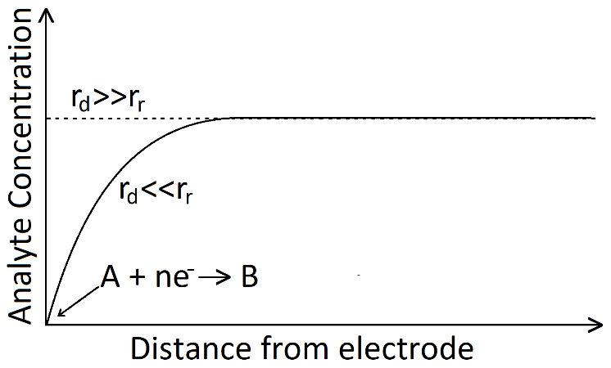

Figure 3: Concentration distribution of analyte (A) for different current limit conditions.

* 1. Amperometric electrochemical sensors: These operate by performing electrochemical reactions with the target gas and producing an electric current. Most commercially available electrochemical gas analysers are amperometric sensors. The principle of amperometric sensing is the measurement of the current-potential relationship in an electrochemical cell in non-equilibrium conditions. The current is directly related to the rate of the electrochemical process at the working electrode whose potential commonly is kept constant using a reference electrode (with the application of a potentiostat)[65]. When the required potential is applied between the electrodes, electroactive species in the electrolyte participate in an electrochemical reaction on the surfaces of each of the electrodes. A reduction reaction occurs at the cathode and at the same time, an oxidation reaction takes place at the anode (in the se of CO detection)[66]. By the virtue of electron flow from oxidative anode to the cathode, a current is generated. This is an illustration of Faraday’s Law as shown below, which states that electrons are generated or used stoichiometrically per each target gas molecule and so the charge (the number of electrons or Coulombs of charge) is related to the number of analyte molecules reacting in the system and the current (electron flow per second) at the electrode is proportional to the rate of the electrochemical reactions[67].

*I=nFDC*

Where *I* is the current, n is the number of electrons transferred, F is the Faraday constant, D is the mass transfer coefficient, and C is the bulk gas concentration. In the case of CO detection, carbon monoxide is oxidised at the interface of the working electrode via the gas interface through the gas membrane as shown in the diagram below[68]. Several factors as mentioned previously such as the characteristics of the gas membrane (permeability and selectivity), nature of the electrolyte and electrode (chemical activity of electrodes towards target gas) decide the overall detection capabilities of the sensor[69].

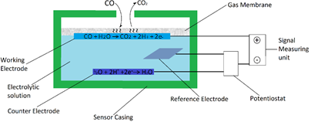

Figure 4: Illustration of amperometric gas sensor for CO with three electrode configuration

A simple three electrode CO amperometric gas sensor may be designed as shown above. The cell consists of a sensor casing for the entire assembly with an opening allowing inflow of the ambient gas. The cell consists of three main electrodes under a constant potential i.e. the working electrode (anode) where the oxidation reaction shall take place, the counter electrode where the reduction reaction shall take place and a reference electrode in order to attain a standard potential reference. Generally, the working electrodes is made from a noble metal, for example Platinum or Gold since noble metals exhibit high stability under acting potential which might otherwise trigger reaction of electrode material itself if not inert in nature. They can also effectively catalyse target gas reactions[70]. The counter electrode is usually made out of Platinum as is it stable with most electrolytes and efficiently performs the complementary half-cell reaction that is opposite of the analyte reaction[71]. A potentiostat is also used in the setup to allow for a constant potential[72]. A reference electrode is present when a potentiostat is used. The reference electrode must form a stable potential with the electrolyte, be compatible with the sensor manufacture and not be sensitive to temperature (T), pressure (P), relative humidity (RH), or other contaminants or reactants in the sensor system. The reference electrode must be able to maintain the working electrode at a constant electrochemical potential during the sensing application. An Ag/AgCl reference electrode, which shows good reversibility, is commonly used for this purpose. Ambient gas diffusion takes place through the gas membrane where electrochemical reaction can take place on the working electrode. In the case of CO, an oxidation reaction takes place by releasing an electron. Depending upon the concentration of the CO in ambient air, number of electron increases and so does the current flowing across the cell. This is then used as a signal[73]. In the above case, dil. H2SO4 is considered to be the electrolyte. As per the equations in Fig. 3, the overall equation for the cell may be written as follows[74]:

CO + 1/2O 🡪 CO2

AGS have been studied extensively for commercial application. Yasuda et. al[75] constructed a solid state planar sensor using a proton conducting membrane and Au/Pt electrodes on a glass substrate. An average response time of 30 s was obtained at a range of 2000 ppm. A sensitivity of 0.04nA/ppm was also recorded. The sensor life was estimated to be about 2 years. Chen et. al[76] developed a novel electrochemical sensor based on nano-Au colloid modified on Pt disk microelectrode for CO detection. A coherent AGS linear profile was obtained for the sensor response. A response time of 7s was obtained. A sensor could detect CO concentrations as low as 0.65ppm. A linear current and concentration correlation was generated: I(A) = 0.00917 (µgml−1) + 0.151. Guan et. al[77] fabricated a novel amperometric CO sensor using Nafion and Pt/C composite electrodes. Several carbon nano-structures were used for Pt loading and evaluated on the basis of their performance (carbon fibers (CFs) > multi-wall carbon nano-tubes (MWCNTs) > carbon blacks; CBs). The sensor using Pt/CFs as the sensing electrode showed the highest sensitivity with the value of 0.077 µA/ppm and shortest response time (28 s response time and 32 s recovery time) in the range of CO concentration from 1 to 200 ppm at room temperature. Santosh el. al[78] developed a novel amperometric sensor based on multi-wall carbon nanotubes (MWNT) grafted polydiphenylamine (PDPA), MWNT-g-PDPA for CO detection. A linear response profile was obtained and the sensor was found to be highly sensitive capable of detecting concentrations as low as 0.01ppm, though the optimal response was obtained for concentration range of 10-200ppm. An amperometric electrochemical sensor based on LaGaO3 was demonstrated as highly sensitive to carbon monoxide (CO) in the temperatures ranging from 300°C to 500°C by Phawachalotorn et. al[79]. A sensor configuration Au10%wt-ITO995/LSGF 82851/RuO2-LSC64 was fabricated. It was found that a response and recovery time of 2-3 min was obtained. The sensor selectivity was also evaluated against other reducing gases. Furthermore, although sensor response was significant for the previously stated range, the response was amplified for higher temperatures.

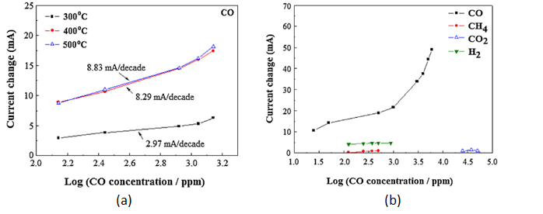

Figure 3: (a). Current change of the sensor as a function of temperature. (b). Cross-sensitivity of lanthanum gallate-based electrochemical sensor to various coexisting gases at 400◦C.

In another study, a humidity-independent Solid-State Amperometric gas Sensor for Carbon Monoxide was developed by Cox et. al[80]. A linearized plot was obtained increasing CO concentrations (tested from 0-25pptv) at room temperature (20°C±5°C).

* 1. Potentiometric electrochemical sensor: These sensors function by generating a potential across the external circuit by the virtue of concentration difference that exists on each of the electrodes. These sensors also function on the principle of electroanalysis and have gained increasing interest as high temperature gas sensors for combustible gases (NOx, CO and HCs) over the past few years[81][82][83][84]. Potentiometric sensors, unlike amperometric sensors give out a logarithmic response to changes in the concentration of the sample gas as compared to the reference gas. An EMF is generated across the two electrodes across the two electrodes as a result of changing oxygen concentration of gases on the electrode surfaces. Since these sensors are manufactured to operate at high temperatures, they use a solid ionic conductor as the electrolyte. A ceramic ion-conducting electrolyte is in contact with two catalytic active metals which is exposed to two different atmospheres: the measuring one and a reference atmosphere (whose composition is known)[85].

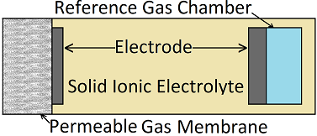

Figure 5: Schematic structure of a potentiometric planar oxygen sensor.

The sensor is exposed to the measuring atmosphere via the porous permeable gas membrane. This layer is optional as it prevents from electrode degradation and sometimes it improves the sensor response due to gas species diffusion. The Measuring electrode, catalytically active, generally made of platinum is placed in contact with the layer to be exposed to the measuring atmosphere in a controlled manner. O**2−** ion-conductive ceramic electrolyte is used. The most used electrolyte is Y2O3-doped ZrO2 (YSZ). The Reference electrode is in contact with the reference atmosphere. Some sensors have been occasionally described without a reference atmosphere. Also, a heating element (a dissipative low resistance) is optionally put in front of this sensor structure to achieve stable, high enough temperatures. Since ionic conduction is a temperature activated phenomena, at about 600K- 650K (since ionic conduction occurs because of the formation of structural defects in the ceramic structure[86]), a heating element is often built into the sensor (near the sensing cell) in order to obtain high yet stable temperatures to allow for conduction. The response of potentiometric gas sensors should ideally follow Nernst Equation which is as should below:

where kB is Boltzmann’s constant, T is the temperature, e the elementary charge, p∗O2, REF is the partial pressure of O2 in the reference gas & p∗O2 is the O2 partial pressure in the measuring gas. The term kBT/4e is frequently referred as RT/4F, which is exactly the same. Since a logarithmic response is generated by the sensor, the sensitivity shall reduce significantly for lower concentrations of oxygen (in the magnitude of 1-10% concentration[87]). However, since catalytically active materials are used as the electrodes, reducing gases such as carbon monoxide and hydrocarbons, can react with the oxygen. Since oxidation of such species will deplete the oxygen concentration at the electrode film, the sensor will show high voltages (~1V) when exposed to non-equilibrated mixtures containing reducing gases and oxygen. Therefore, the Nernst equation shall still hold true but not for O2 concentration in the non-equilibrated bulk gas and only for non-equilibrated gas mixtures near the Pt electrodes. These sensors are essentially oxygen concentration galvanic cells[88]. At stable conditions, a constant potential is detected across the sensor as the following half-cell reactions proceeds:

02 +O2 + 4e- 🡪 2O2- Cathode reaction at I

2O2- 🡪 O2 + 4e- Anode reaction at II

As shown above, at concentration I at the cathode, oxygen molecules are ionized to form the O2- ions and these ions recombine at the anode at concentration II. Assuming a concentration gradient exists between concentration I and II, the Nernst equations obtained is as follows:

The above is the steady state response of a potentiometric gas sensor. In the presence of a reducing gas such as carbon monoxide with a cell configuration PO2I, Pt/yttria stabilized ZrO2/Pt, PO2II, CO shall adsorb onto the Pt electrodes[89]. Upon adsorption onto the Pt electrode, the CO molecules shall undergo electrochemical oxidation reaction with the surficial oxygen and hence deplete the local oxygen partial pressure near the measuring electrode via the reaction:

2CO + O2 ⇌ 2CO2

A potential drop shall occur across the two electrodes after the above reaction which shall be responsible for the ideal equilibrium Nernst voltage in the reducing mixtures. At the triple phase boundary, CO shall deplete the oxygen ion concentration at the electrolyte surface near the measuring electrode hence affecting the voltage as shown below:

CO(gas) + O2-(electrolyte) ⇌ CO2(gas) + 2e-

Hence the open circuit voltage resulting from the above two reactions can be obtained as the following expression.

Vout = α*Vreaction O2 + β*Vreaction CO

The above model for potentiometric gas sensors is known as Fleming’s model[90]. It accounts for the Nernstian voltages which exist by the virtue of the electrochemical reaction of carbon monoxide and oxygen. Most potentiometric sensors work essentially as oxygen concentration sensor. For example, Li et. al.[91] developed a high-temperature potentiometric CO sensor by coating a mixture of CuO/ZnO over one of the platinum electrodes of a cell with a yttria-stabilized zirconia solid electrolyte. It showed good CO sensing characteristics over the temperature range of 450-550°C and concentration range of 0-10,000 ppm of CO in air. In particular, high sensitivity coupled with reasonably fast response (< 2 min at about 450°C) and baseline recovery characteristics were observed at 450°C for CO concentrations below 3,000 ppm. Miura et. al[92] developed a CO selective potentiometric sensor by using oxide electrodes over stabilized zirconia. YSZ tubes were used and Pt reference electrodes were contacted with the inner tube which was always exposed to atmospheric air. In order to deposit active layer on the outer electrode, hydrolysis of aqueous solutions of corresponding metal chlorides or by thermal decomposition of corresponding metal nitrates was done. It was found that the combination of CdO and SnO2 was best suited for the electrode couple, giving quick and selective response to CO in air at 600°C. The 90% response and the 90% recovery times of the sensor to 200 ppm CO was as short as 8 s and 10 s, respectively, at 600°C. The EMF value was linearly related with the logarithm of CO concentration in the range of 20 to 4000 ppm. Park et. al[93] developed a miniature potentiometric, solid‐state, carbon monoxide (CO) sensors with semiconducting oxide electrodes. The sensor characteristics were investigated over the temperature range 500°–700°C and it was found that a wide detection range of 0-16,000ppm was obtained at different temperature ranges. Furthermore, the response was logarithmic in nature. Following response equation was thus obtained for one of the cells tested (TiO2 (anatase) electrode).



Figure 3: Dependence of voltage response as a function of carbon monoxide (CO) concentration (base gas: N2 13% O2 in wet condition).

Response time of < 2 min was obtained which was further improved upon by increased CO concentration and by increasing the temperature. Zhu et. al[94] explored PdO oxide sensing electrode based potentiometric. Palladium was deposited onto the YSZ by hydrolysis of palladium acetate and centrifugal separation of obtain metallic palladium which was calcined onto the substrate at 750°C at 2h in air. The sensor was more selective towards CO than other exhaust gases but had a decent response to propane at concentration of above 100ppm. A response and recovery time of 11 and 138 seconds was obtained. The sensor also had repeatability for the tested 5h and 10h. Goto et. al[95] explored the CO-sensing properties of potentiometric gas sensors using an anion- conducting polymer electrolyte and Au-loaded metal oxide electrodes. Three metal oxides namely In2O3, Co3O4 and ZnO were used as electrode support materials onto which Au was loaded for enhanced sensitivity and selectivity. Though the sensor was cross-sensitive towards H2 along with CO, it was found that the response to CO was significantly greater than H2. Furthermore, it was found that The magnitude of responses of all the sensors to CO and H2 increased in proportion to the logarithm of CO and H2 concentrations, respectively. The response to low concentration of CO increased with an increase in the loading amount of Au, while the response to high concentration of CO increased only slightly by increasing the loading amount of Au. The response time as recorded by the group have been tabulated as follows:

*Table 3: 90% response and recovery times of all the sensors* **95**

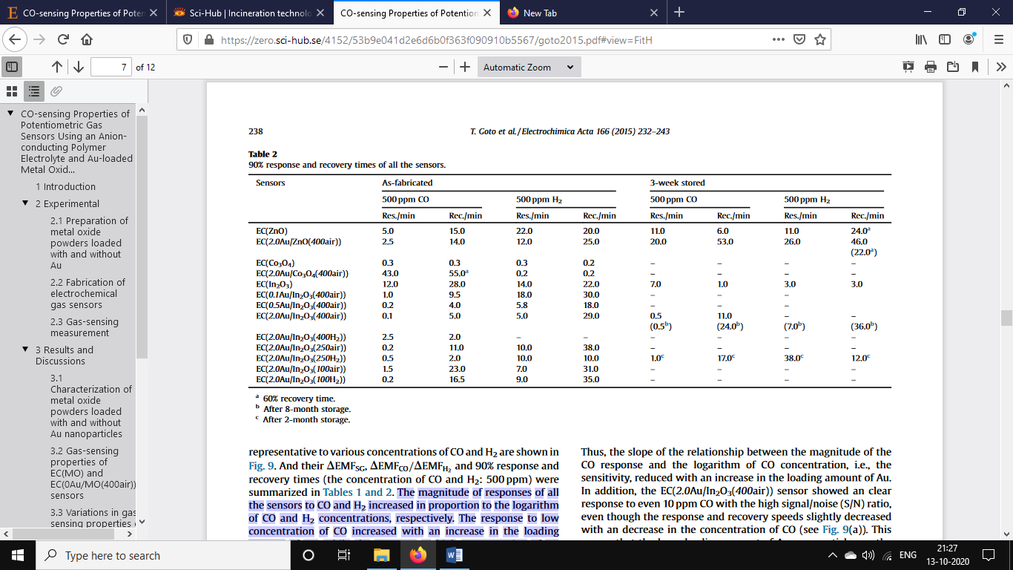

Hyodo et. al[96] developed an electrochemical CO sensors utilizing Pt-loaded SnO2 electrodes and an anion-conducting polymer electrolyte. Response and recovery time profiles were obtained as follows:

*Table 3: Typical 90% response time (TRS) and 70% recovery time (TRC) of EC(2Pt/SnO2(500air)) and EC(2Pt/SnO2(250H2)) sensors to CO and H2.*

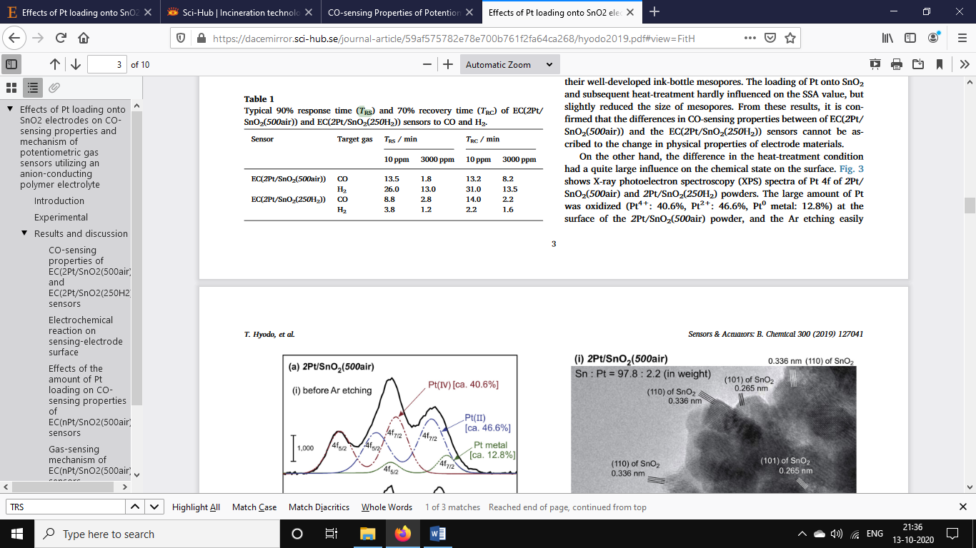

Guilette et al[97] test the role of O2 and CO on a sensing device composed of a solid electrolyte (Na-β-alumina) associated with two metal electrodes, one in platinum the other in gold. The response was tested between 250-600°C and it was found that the response for higher concentrations increased as the temperature rose. Furthermore, the response also depended heavily on the oxygen pressure in the reference and it increased as the pressure increased. Concentrations were measured between 10-200 ppm and a response time of 20s was recorded.

1. Olhoff, Anne & Partnership, John & Kuramochi, Takeshi & Rogelj, Joeri & Höhne, Niklas & Jiang, Kejun & Fransen, Taryn. (2019). Emissions Gap Report 2019. 10.13140/RG.2.2.10672.10243.
2. Respiratory Health–Air Pollution, Boston University School of Public Health. Available online: <http://sphweb.bumc.bu.edu/otlt/MPH> Modules/PH/RespiratoryHealth/RespiratoryHealth7.html (accessed on28 September 2018).
3. Varon, J.; Marik, P.E.; Fromm, R.E., Jr.; Gueler, A. Carbon monoxide poisoning: A review for clinicians.J. Emerg. Med. 1999, 17, 87–93.
4. Raub, J.A.; Mathieu-Nolf, M.; Hampson, N.B.; Thom, S.R. Carbon monoxide poisoning—A public healthperspective. Toxicology 2000, 145, 1–14.
5. Respiratory Health–Air Pollution, Boston University School of Public Health. Available online: http://sphweb.bumc.bu.edu/otlt/MPH-Modules/PH/RespiratoryHealth/RespiratoryHealth7.html (accessed on28 September 2018).
6. Harper, A.; Croft-Baker, J. Carbon monoxide poisoning: Undetected by both patients and their doctors.Age Ageing 2004, 33, 105–109.
7. Goldstein, M. Carbon monoxide poisoning. J. Emerg. Nurs. 2008, 34, 538–542.
8. Wei, P.; Ning, Z.; Ye, S.; Sun, L.; Yang, F.; Wong, K.C.; Westerdahl, D.; Louie, P.K.K. Impact Analysis of Temperature and Humidity Conditions on Electrochemical Sensor Response in Ambient Air Quality Monitoring. Sensors **2018**, 18, 59.
9. LEBLANC, S. E., & COUGHANOWR, D. R. (2009). *Process systems analysis and control*. Boston, McGraw-Hill Higher Education
10. Fine, G. F., Cavanagh, L. M., Afonja, A., & Binions, R. (2010). Metal Oxide Semi-Conductor Gas Sensors in Environmental Monitoring. Sensors, 10(6), 5469–5502. doi:10.3390/s100605469
11. Korotcenkov, G. Gas response control through structural and chemical modification of metal oxide films:State of the art and approaches. Sens. Actuator B Chem. 2005, 107, 209–232.
12. Xu, C., Tamaki, J., Miura, N., & Yamazoe, N. (1991). Grain size effects on gas sensitivity of porous SnO2-based elements. Sensors and Actuators B: Chemical, 3(2), 147–155. doi:10.1016/0925-4005(91)80207-z
13. Nandy, T., Coutu, R., & Ababei, C. (2018). Carbon Monoxide Sensing Technologies for Next-Generation Cyber-Physical Systems. Sensors, 18(10), 3443. doi:10.3390/s18103443
14. Fundamentals of Metal Oxide Gas Sensors, 14th International Meeting on Chemical Sensors - IMCS 20122012-05-20 - 2012-05-23Nürnberg/Nuremberg, Germany, 7.3 Metal Oxide-based Gas Sensors VII, N. Barsan, U. Weimar - Institute of Physical and Theoretical Chemistry, University of Tuebingen (Germany), p618 - 621, DOI: 10.5162/IMCS2012/7.3.3
15. W.E. Spear, P.G. Le Comber, Substitutional doping of amorphous silicon, SolidState Commun. 17 (1975) 1193–1196.
16. D. Szczuko, J. Werner, S. Oswald, G. Behr, K. Wetzig, XPS investigations ofsurface segregation of doping elements in SnO2, Appl. Surf. Sci. 179 (2001)301–306. C
17. Kilic, A. Zunger, Origins of coexistence of conductivity and transparency inSnO2, Phys. Rev. Lett. 88 (2002) 095501.
18. M. Batzill, U. Diebold, The surface and materials science of tin oxide, Prog.Surf. Sci. 79 (2005) 47–154.
19. J. Feinleib, D. Adler, Band structure and electrical conductivity of NiO, Phys.Rev. Lett. 21 (1968) 1010–1013.
20. Kim, H.-J., & Lee, J.-H. (2014). *Highly sensitive and selective gas sensors using p-type oxide semiconductors: Overview. Sensors and Actuators B: Chemical, 192, 607–627.* doi:10.1016/j.snb.2013.11.005 
21. C.O. Park, S.A. Akbar, Ceramics for chemical sensing, J. Mater. Sci. 38 (2003)4611–4637.
22. N. Barsan, U. Weimer, Conduction model of metal oxide gas sensors, J. Elec-troceram. 7 (2001) 143–167.
23. Kolmakov, A.; Zhang, Y.; Cheng, G.; Moskovits, M. Detection of CO and O2 using tin oxide nanowire sensors.Adv. Mater. 2003, 15, 997–1000
24. Brunet, E., Maier, T., Mutinati, G. C., Steinhauer, S., Köck, A., Gspan, C., & Grogger, W. (2012). Comparison of the gas sensing performance of SnO2 thin film and SnO2 nanowire sensors. Sensors and Actuators B: Chemical, 165(1), 110–118. doi:10.1016/j.snb.2012.02.025
25. Du, X.; George, S.M. Thickness dependence of sensor response for CO gas sensing by tin oxide films grown using atomic layer deposition. Sens. Actuators B Chem. **2008**, 135, 152–160. [CrossRef]
26. Kim, J.-H., Mirzaei, A., Kim, H. W., & Kim, S. S. (2020). Variation of shell thickness in ZnO-SnO2 core-shell nanowires for optimizing sensing behaviors to CO, C6H6, and C7H8 gases. Sensors and Actuators B: Chemical, 302, 127150. doi:10.1016/j.snb.2019.127150
27. Zhao, L.; Choi, M.; Kim, H.S.; Hong, S.H. The effect of multiwalled carbon nanotube doping on the CO gassensitivity of SnO2-based nanomaterials. Nanotechnology 2007, 18, 445501. [CrossRef]
28. Kocemba, I., & Rynkowski, J. (2011). The influence of catalytic activity on the response of Pt/SnO2 gas sensors to carbon monoxide and hydrogen. Sensors and Actuators B: Chemical, 155(2), 659–666. doi:10.1016/j.snb.2011.01.026
29. Bahrami, B., Khodadadi, A., Kazemeini, M., & Mortazavi, Y. (2008). Enhanced CO sensitivity and selectivity of gold nanoparticles-doped SnO2 sensor in presence of propane and methane. Sensors and Actuators B: Chemical, 133(1), 352–356.
30. Moon, W. J., Yu, J. H., & Choi, G. M. (2002). The CO and H2 gas selectivity of CuO-doped SnO2–ZnO composite gas sensor. Sensors and Actuators B: Chemical, 87(3), 464–470. doi:10.1016/s0925-4005(02)00
31. Kumar, A., Sanger, A., Kumar, A., & Chandra, R. (2016). Highly sensitive and selective CO gas sensor based on a hydrophobic SnO2/CuO bilayer. RSC Advances, 6(52), 47178–47184. doi:10.1039/c6ra06538d
32. Nanostructured SnO2–ZnO composite gas sensors for selective detection of carbon monoxide, Paul Chesler, Cristian Hornoiu, Susana Mihaiu, Cristina Vladut, Jose Maria Calderon Moreno, Mihai Anastasescu, Carmen Moldovan, Bogdan Firtat, Costin Brasoveanu, George Muscalu, Ion Stan and Mariuca GartnerBeilstein J. Nanotechnol. 2016, 7, 2045–2056. doi:10.3762/bjnano.7.195
33. Al-Homoudi, I. A., Thakur, J. S., Naik, R., Auner, G. W., & Newaz, G. (2007). Anatase TiO2 films based CO gas sensor: Film thickness, substrate and temperature effects. Applied Surface Science, 253(21), 8607–8614.
34. Moon, H.G.; Shim, Y.S.; Jang, H.W.; Kim, J.S.; Choi, K.J.; Kang, C.Y.; Choi, J.W.; Park, H.H.; Yoon, S.J. Highly sensitive CO sensors based on cross-linked TiO2 hollow hemispheres. Sens. Actuators B Chem. 2010, 149,116–121.
35. Lee, J.S.; Ha, T.J.; Hong, M.H.; Park, C.S.; Park, H.H. The effect of multiwalled carbon nanotube doping onthe CO gas sensitivity of TiO2 xerogel composite film. Appl. Surf. Sci. 2013, 269, 125–128.
36. Kim, H.J.; Lee, J.H. Highly sensitive and selective gas sensors using p-type oxide semiconductors: Overview. Sens. Actuators B Chem. **2014**, 192, 607–627.
37. Barsan, N.; Simion, C.; Heine, T.; Pokhrel, S.;Weimar, U. Modeling of sensing and transduction for p-type semiconducting metal oxide based gas sensors. J. Electroceramics **2010**, 25, 11–19.
38. Wisitsoraat, A., Tuantranont, A., Comini, E., Sberveglieri, G., & Wlodarski, W. (2009). Characterization of n-type and p-type semiconductor gas sensors based on NiOx doped TiO2 thin films. Thin Solid Films, 517(8), 2775–2780.
39. Wöllenstein, J., Burgmair, M., Plescher, G., Sulima, T., Hildenbrand, J., Böttner, H., & Eisele, I. (2003). Cobalt oxide based gas sensors on silicon substrate for operation at low temperatures. Sensors and Actuators B: Chemical, 93(1-3), 442–448.
40. Tan,W.; Tan, J.; Li, L.; Dun, M.; Huang, X. Nanosheets-assembled hollowed-out hierarchical Co3O4 microrodsfor fast response/recovery gas sensor. Sens. Actuators B Chem. 2017, 249, 66–75.
41. 27[34]H.-M. Jeong, J.-H. Kim, S.-Y. Jeong, C.-H. Kwak, J.-H. Lee, Co3O4–SnO2Hollow heteronanostructures: facile control of gas selectivity by compositional tuning of sensing materials via galvanic replacement, ACS Appl. Mater. Interfaces. 8 (2016) 7877–788
42. Al-Kuhaili, M.F.; Durrani, S.M.A.; Bakhtiari, I.A. Carbon monoxide gas-sensing properties of CeO2–ZnOthin films. Appl. Surf. Sci. 2008, 255, 3033–3039
43. Kim, J.H.; Lee, J.H.; Mirzaei, A.; Kim, H.W.; Kim, S.S. Optimization and gas sensing mechanism of n-SnO2-p-Co3O4 composite nanofibers. Sens. Actuators B Chem. **2017**, 248, 500–511
44. Huang H., Gong H., Chow C.L., Guo J., White T.J., Tse M.S., Tan O.K. Low-Temperature Growth of SnO2 Nanorod Arrays and Tunable n-p-n Sensing Response of a ZnO/SnO2 Heterojunction for Exclusive Hydrogen Sensors. Adv. Funct. Mater. 2011;21:2680–2686. doi: 10.1002/adfm.201002115.
45. Gong J., Li Y., Hu Z., Zhou Z., Deng Y. Ultrasensitive NH3 Gas Sensor from Polyaniline Nanograin Enchased TiO2 Fibers. J. Phys. Chem. C. 2010;114:9970–9974. doi: 10.1021/jp100685r.
46. Wu, R.-J., Hu, C.-H., Yeh, C.-T., & Su, P.-G. (2003). Nanogold on powdered cobalt oxide for carbon monoxide sensor. Sensors and Actuators B: Chemical, 96(3), 596–601. doi:10.1016/s0925-4005(03)00646-4
47. Simões, F. R., & Xavier, M. G. (2017). Electrochemical Sensors. Nanoscience and Its Applications, 155–178. doi:10.1016/b978-0-323-49780-0.00006-5
48. F.J. Holler, D.A. Skoog, S.R. Crouch, Principles of Instrumental Analysis, sixth edition, Thomson Brooks/ Cole, 2007.
49. Amperometric Gas Sensors A Review Joseph R. Stetter and Jing L iChemical Reviews 2008 108 (2), 352-366DOI: 10.1021/cr0681039
50. Bjarne R. S. Hansen, Mark Paskevicius, Mathias Jørgensen, Torben R. Jensen, Halogenated Sodium- closo -Dodecaboranes as Solid-State Ion Conductors , Chemistry of Materials, 10.1021/acs.chemmater.6b04797, 29, 8, (3423-3430), (2017).
51. F. A. Kroger: The Chemistry of Imperfect Crystals. North-Holland, Amsterdam 1964, pp. 207ff.
52. C. Wagner, W Schottky, Z. Phys. Chem. Ell, 163 (1930).
53. J. Frenkel, Z. Phys. 35, 652 (1926).
54. Chen, C., Eichel, R.-A., & Notten, P. H. L. (2018). Ionic conductivity of metal oxides: An essential property for all-solid-state lithium-ion batteries. Metal Oxide-Based Thin Film Structures, 361–4
55. Stetter, J. R.; Butner, W. J.; Cao, Z. Electroanalysis 1992, 4.
56. Stetter, J. R.; Chang, S. C.; Cha, C. S. Talanta 1993, 40.
57. T. Jacobsen, B. Zachau-Christiansen, L. Bay, and M. Juhl,“Hysteresis in the solid oxide fuel cell cathode reaction,”Electrochimica Acta, vol. 46, no. 7, pp. 1019–1024, 2001.
58. R. J. Aaberg, R. Tunold, and R. Odegard, “On the electrochemistry of metal-YSZ single contacts,” Solid State Ionics,vol. 136-137, pp. 707–712, 2000.
59. S. Sridhar, V. Stancovski, and U. B. Pal, “Effect of oxygen containing species on the impedance of the Pt/ YSZ interface,”Solid State Ionics, vol. 100, no. 1-2, pp. 17–22, 1997.
60. L. Bultel, P. Vernoux, F. Gaillard, C. Roux, and E. Siebert,“Electrochemical and catalytic properties of porous Pt-YSZ composites,” Solid State Ionics, vol. 176, no. 7-8, pp. 793–801,2005.
61. N.Miura, T. Raisen, G. Lu, and N. Yamazoe, “Highly selectiveCO sensor using stabilized zirconia and a couple of oxide electrodes,” Sensors and Actuators B, vol. 47, no. 1–3, pp. 84–91, 1998.
62. H. Fukunaga, M. Ihara, K. Sakaki, and K. Yamada, “The relationship between over potential and the three phase boundary length,” Solid State Ionics, vol. 86–88, pp. 1179–1185, 1996.
63. M. Juhl, S. Primdahl, C. Manon, and M. Mogensen, “Performance/structure correlation for composite SOFC cathodes,” Journal of Power Sources, vol. 61, no. 1-2, pp. 173–181, 1996.
64. S. P. Yoon, S. W. Nam, J. Han, T. H. Lim, S. A. Hong, andS. H. Hyun, “Effect of electrode microstructure on gas-phase diffusion in solid oxide fuel cells,” Solid State Ionics, vol. 166,no. 1-2, pp. 1–11, 2004.
65. Xing, X. K.; Liu, C. C. *Electroanalysis* **1991**, *3*, 111.
66. Stetter, J. R.; Penrose, W. R. Understanding Chemical Sensors andChemical Sensor Arrays (Electronic Noses): Past, Present, andFuture. In Sensors Update; Wiley-VCH: Weinheim, Germany, 2002;Vol. 10, Chapter 2.3, p 189.
67. Fuller, T. F., & Harb, J. N. (2018). *Electrochemical engineering*.
68. Janata, J. Principles of Chemical Sensors; Plenum Press: New York,1989.
69. Chao, Y.; Buttner, W. J.; Yao, S.; Stetter, J. R. Sens. Actuators, B2005, 106 (2), 784.
70. Stetter, J. R.; Butner, W. J.; Cao, Z. *Electroanalysis* **1992**, 4.
71. Stetter, J. R.; Chang, S. C.; Cha, C. S. *Talanta* **1993**, 40.
72. Wallgren, K.; Sotiropoulos, S. *Sens. Actuators, B* **1999**, 60.
73. Li, J.; Lu, Y.; Ye, Q.; Delzeit, L.; Meyyappan, M. Electrochem. SolidState Lett. 2005, 8 (11), H100.
74. Qi, P.; Vermesh, O.; Grecu, M.; Javey, A.; Wang, Q.; Dai, H.; Peng,S.; Cho, K. J. Nano Lett. 2003, 3 (3), 347.
75. Electrochemical carbon monoxide sensor with a Nafion film, Yasuda, Shimidzu, Reactive & Functional Polymers 41 (1999) 235–243, 1999
76. Chen, C., He, J., Xu, D., Tan, X., Zhou, X., & Wang, X. (2005). Study of nano-Au-assembled amperometric CO gas sensor. Sensors and Actuators B: Chemical, 107(2), 866–871. doi:10.1016/j.snb.2004.12.037
77. Guan, Y., Liu, F., Wang, B., Yang, X., Liang, X., Suo, H., … Lu, G. (2017). Highly sensitive amperometric Nafion-based CO sensor using Pt/C electrodes with different kinds of carbon materials. Sensors and Actuators B: Chemical, 239, 696–703. doi:10.1016/j.snb.2016.08.034
78. Santhosh, P., Manesh, K. M., Gopalan, A., & Lee, K.-P. (2007). Novel amperometric carbon monoxide sensor based on multi-wall carbon nanotubes grafted with polydiphenylamine—Fabrication and performance. Sensors and Actuators B: Chemical, 125(1), 92–99. doi:10.1016/j.snb.2007
79. Phawachalotorn, C., Sanguanruang, O., & Ishihara, T. (2012). Highly selective amperometric sensors for carbon monoxide detection in exhaust gas. Sensors and Actuators B: Chemical, 161(1), 635–640.
80. Tess, M. E., & Cox, J. A. (1998). Humidity-Independent Solid-State Amperometric Sensor for Carbon Monoxide Based on an Electrolyte Prepared by Sol−Gel Chemistry. Analytical Chemistry, 70(1), 187–190. doi:10.1021/ac9708396 
81. Li X, Kale G (2006) ECS Trans 3(10):45
82. Park CO, Fergus JW, Miura N, Park J, Choi A (2009) Ionics 15(3): 261
83. Striker T, Ramaswamy V, Armstrong EN, Willson PD, Wachsman ED, Ruud JA (2013) Sensors Actuators B Chem 181(0):312
84. Fergus JW (2007) Sensors Actuators B Chem 122(2):683
85. López-Gándara, C., Ramos, F. M., & Cirera, A. (2009). *YSZ-Based Oxygen Sensors and the Use of Nanomaterials: A Review from Classical Models to Current Trends. Journal of Sensors, 2009, 1–15.* doi:10.1155/2009/258489 
86. Okamoto H, Obayashi H and Kudo T 1980 Solid State Ion. 1319
87. Bakker E, Pretsch E, Buhlmann P. Selectivity of potentiometric ion sensors. Anal Chem.2000;72:1127-1133
88. D. W. McKee, “Interaction of hydrogen and carbon monoxideon platinumgroup metals,” Journal of Catalysis, vol. 8, no.3, pp. 240–249, 1967.
89. E. M. Logothetis, in Chemical Sensor Technology, Vol.3, N. Yamazoe, Editor, p. 89, Kodansha and Elsevier,Tokyo (1991).
90. W. J. Fleming, “Physical principles governing non ideal behaviour of the zirconia oxygen sensor,” Journal of the Electrochemical Society, vol. 124, pp. 21–28, 1977.
91. Li, N., Tan, T.C., Zeng, H.C. (1993-04). High-temperature carbon monoxide potentiometric sensor. Journal of the Electrochemical Society 140 (4) : 1068-1073. Scholar Bank @NUS Repository.
92. Miura, N. (1997). Zirconia-Based Potentiometric Sensor Using a Pair of Oxide Electrodes for Selective Detection of Carbon Monoxide. Journal of The Electrochemical Society, 144(7), L198. doi:10.1149/1.1837798 
93. Park, J.-Y., Azad, A.-M., Song, S.-J., & Wachsman, E. D. (2010). Titania-Based Miniature Potentiometric Carbon Monoxide Gas Sensors with High Sensitivity. Journal of the American Ceramic Society, 93(3), 742–749. doi:10.1111/j.1551-2916.2009.03446.x
94. Zhu, L., Zheng, Y., & Jian, J. (2015). Effect of palladium oxide electrode on potentiometric sensor response to carbon monoxide. Ionics, 21(10), 2919–2926.
95. Goto, T., Hyodo, T., Ueda, T., Kamada, K., Kaneyasu, K., & Shimizu, Y. (2015). CO-sensing Properties of Potentiometric Gas Sensors Using an Anion-conducting Polymer Electrolyte and Au-loaded Metal Oxide Electrodes. Electrochimica Acta, 166, 232–243
96. Hyodo, T., Goto, T., Takamori, M., Ueda, T., & Shimizu, Y. (2019). *Effects of Pt loading onto SnO2 electrodes on CO-sensing properties and mechanism of potentiometric gas sensors utilizing an anion-conducting polymer electrolyte. Sensors and Actuators B: Chemical, 300, 127041.* doi:10.1016/j.snb.2019.127041 
97. Guillet, N. (2004). Oxygen and carbon monoxide role on the electrical response of a non-Nernstian potentiometric gas sensor; proposition of a model. Sensors and Actuators B: Chemical, 98(2-3), 130–139. doi:10.1016/j.snb.2003.10.001